CI CD LAB EXPERIMENT -2

(BY: AMAN TYAGI)

Aim: Jenkins Integration with GitHub

1. Start your Jenkins
2. From manage Jenkins add the plugin for github.
3. Create a new item from Jenkins dashboard

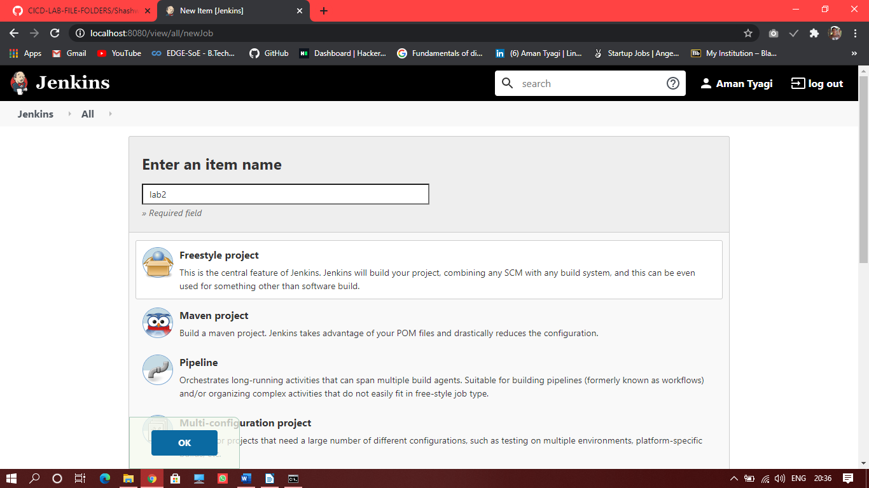

1. Now in the config page add the SCM as Git and enter the link of your repository.

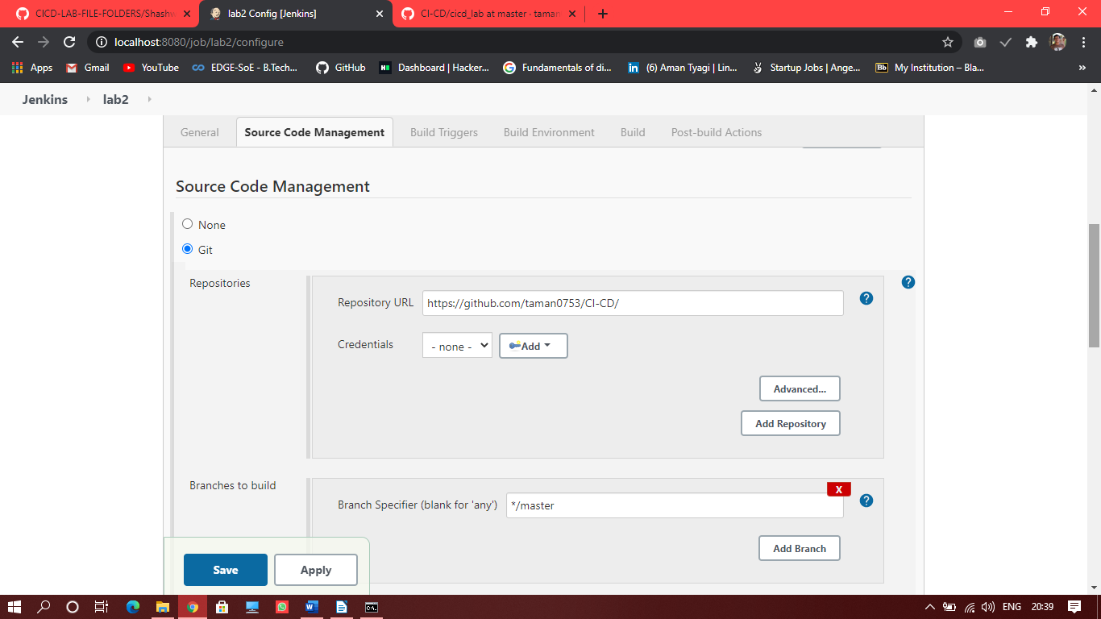

1. Save the changes and now your project has been added to Jenkins.

